Name: Ali Albayrak

Student ID: P304320

Practice Activities 2.3

Vocabulary:

Generic class: This is a special type of class that associates one or more non-specified Java types.

Angle brackets: A type interface diamond is what 2 characters.

Enums: A datatype that contains a fixed set of constants

1.Create a generic class called Cuboid that will store the three dimensions of a cuboid. Add methods to set and get the length, breadth and Height. Add a method public String toString() that will return all of the dimensions. The type of the dimensions will be decided at construction of the cuboid instance.

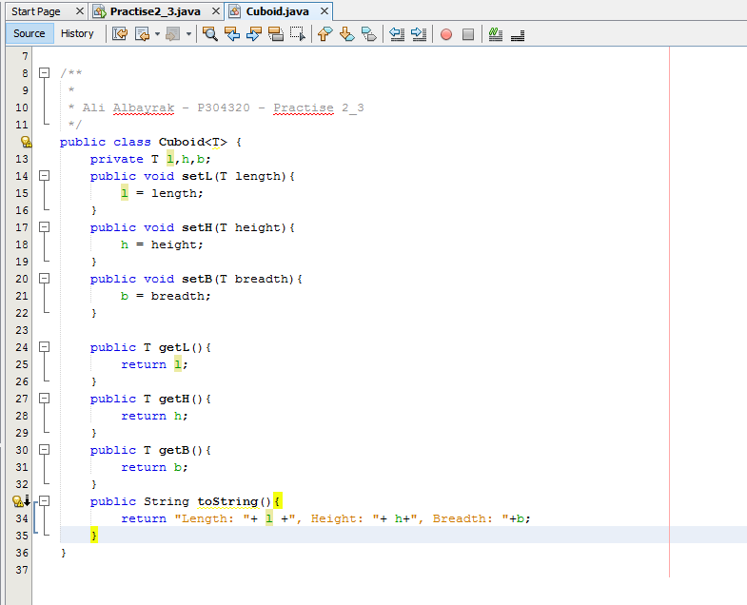

2. Modify your generic class Cuboid so that it only accepts Numbers. Add a method with the following definition and complete its body. Hint: Look at the method doubleValue() in the Number class.

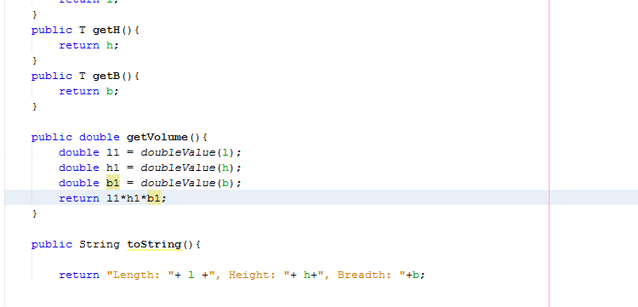

3. A calendar expert, Mr. Dayes, wishes to make a class that will be used to initialize and store the days of the week. Would it be useful for him to use an enum type? Why or why not?

Days of the week are same everytime. So, we know our possibilities of the values. Because of this he can use the enum type.

4.Create a generic class that stores a Key and a Value and call it Map. This will have one method called toString that will return a string that shows the key and the value. The key and the value can be of any type. Test your class by adding the following three years and an associated iconic car to a separate instance of each. You will end up with three instances of Map storing the following data:

Year Car

1989 GT-R

1969 Capri

1953 Corvette C1

